TourKare — AI-Powered Travel Itinerary Planning System
Prepared by: Mohit Dak
MIS - 112415134
IIIT Pune — Software Engineering Lab
Date: 18/9/26

1. Class Diagram
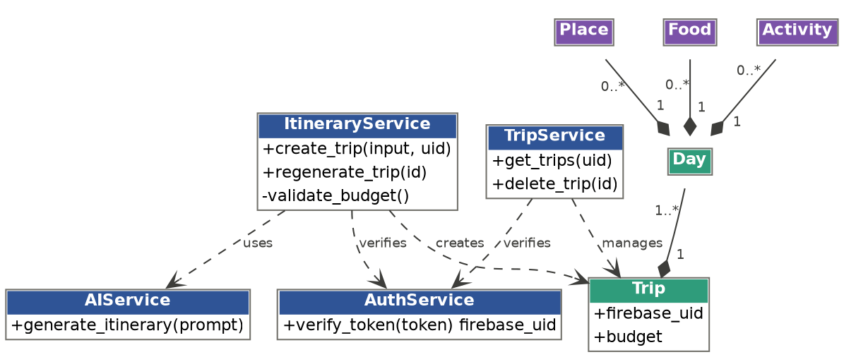
Figure 1: TourKare class diagram

2. Sequence Diagram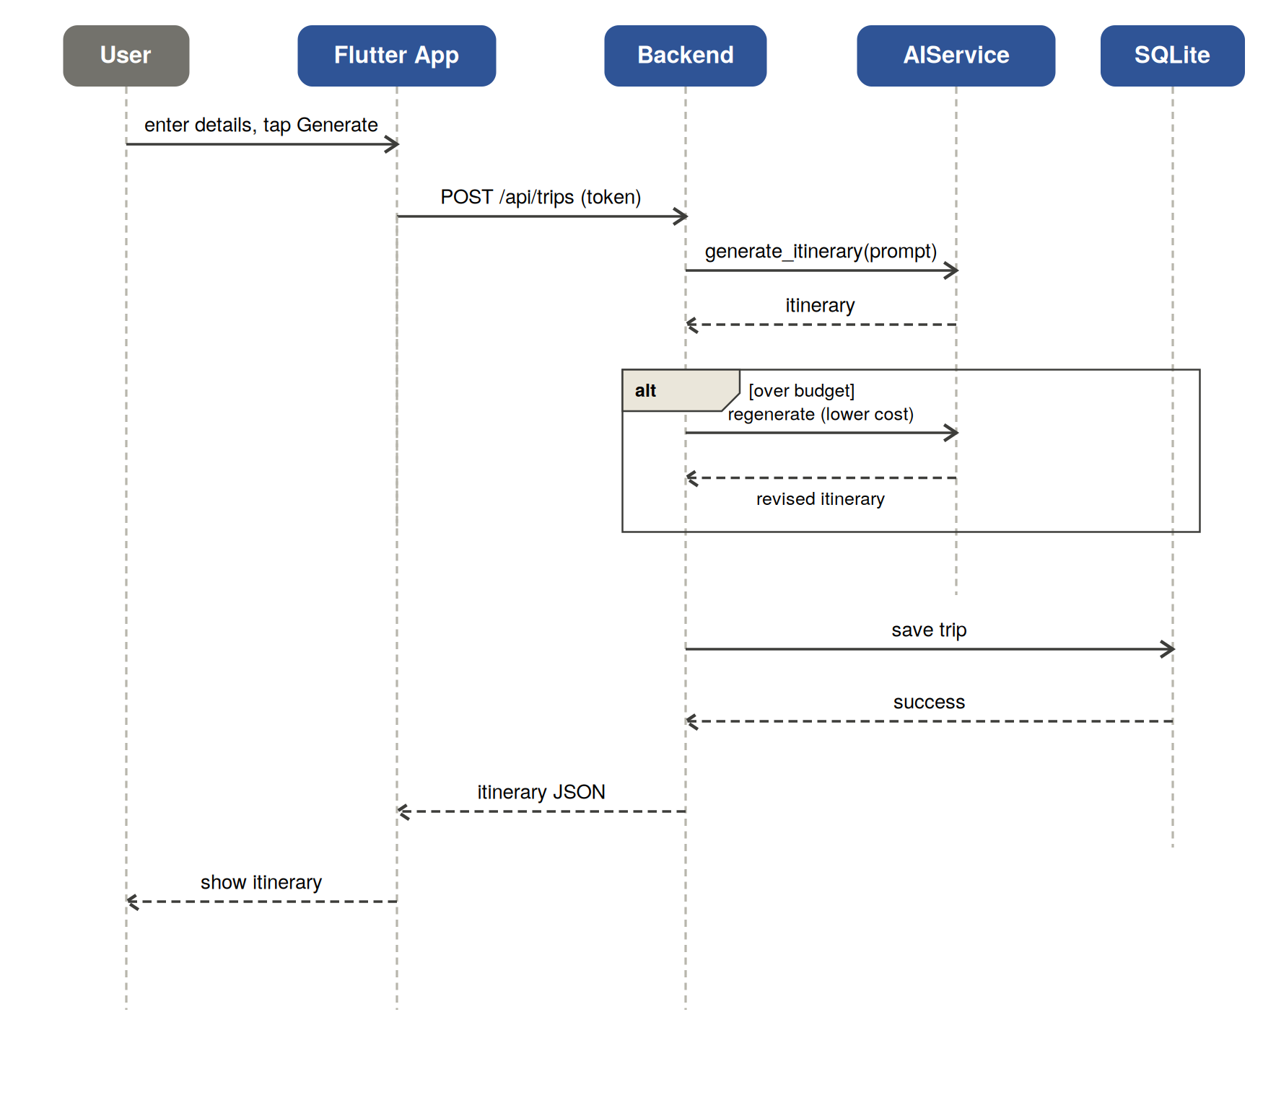
Figure 2: TourKare sequence diagram — generate itinerary

